**Fire Detector Alarm System**

Project Proposal-3

**Tentative Outline:**

|  |  |
| --- | --- |
| 1. | Objective |
| 2. | Equipment   * Requirement Table |
| 3. | Block Diagram of Fire Detector Alarm System |
| 4. | Working Principle |
| 5. | Circuit Diagram of Fire Detector Alarm System |
| 6 | Discussion |

**Project Objective:**

The objective of this project is to implement a cost-effective, reliable **Fire Detector Alarm** **System** that can be used significantly reduce damage and maximize fire control efforts. If anyone is sleeping or busy working, early fire detection will warn them and help them respond quickly so they’ll be out of danger.

**Project Equipment:**

|  |  |
| --- | --- |
| **Products** | **Quantity** |
| Arduino UNO | 1 |
| Solderless Board | 1 |
| MQ-5 GAS Sensor | 1 |
| 16*2 LCD Display | 1 |
| 100R Resistor | 3 |
| 4.7k Resistor | 1 |
| 1k Resistor | 1 |
| LED Green | 1 |
| LED Red | 1 |
| Buzzer | 1 |
| Male-to-Male Jumper Wires | Required |
| Battery clip | 1 |
| Battery 9V | 1 |

**Block Diagram:**

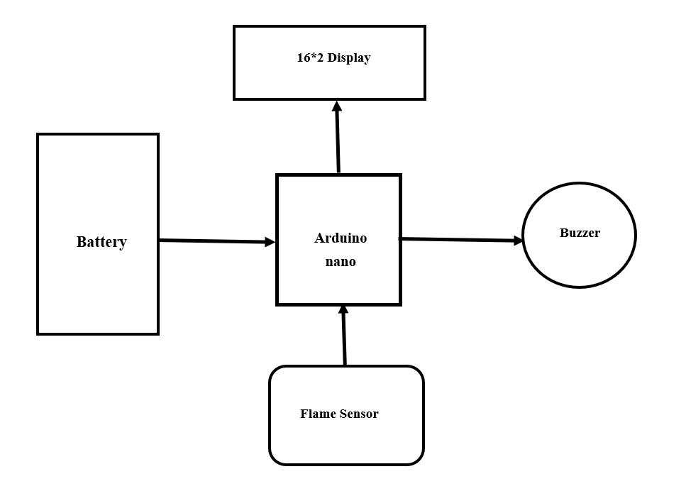

**Fig:** Block diagram of the Fire Detector Alarm System

**Working Principle:**

For building up a Fire detector alarm system, we need a 9V battery which will Arduino nano and flame sensor. The flame sensor will be connected with Arduino nano’s A0 pin. Then a 16*2 LCD display will be used, in which a contrasting pin will be associated with the positive side of the 4.7k resistor, and a 1k resistor will be connected with the ground. In display, backlit pins 15,16 are anode and cathode, respectively.

A flame sensor module consists of a flame sensor (IR receiver), resistor, capacitor, potentiometer, and comparator LM393 in an integrated circuit. It can detect infrared light with a wavelength ranging from 700nm to 1000nm. The far-infrared flame probe converts the light seen in the form of infrared light into current changes. Sensitivity is adjusted through the onboard variable resistor with a detection angle of 60 degrees.

The working voltage is between 3.3v and 5.2v DC, with a digital output to indicate the presence of a signal. Sensing is conditioned by an LM393 comparator.

If holding a flame within 1.5 feet in front of the sensor, "case 0" will be activated, and Close Fire will be sent to the serial monitor. If holding a flame between 1.5 feet and 3 feet in front of the sensor, "case 1" will be activated, and " Distant Fire will be sent to the serial monitor. If no flame is detected in front of the sensor, "case 2" will be activated, and " No Fire " will be sent to the serial monitor. Arduino reads the signal and provides an alert by turning on the buzzer and LED.

**Circuit Diagram:**

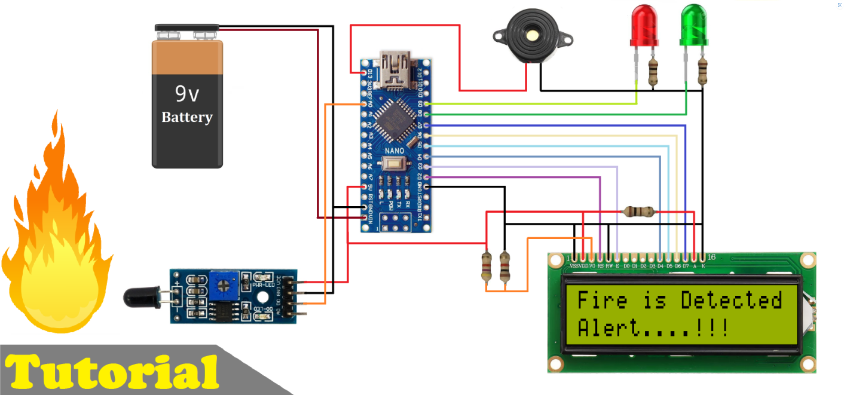

Fig: Circuit diagram of the Fire Detector Alarm System

**Discussion:**

The designed fire alarm system is simple, but it has a wide area of application in household and industrial safety, especially in developing countries. Using this system, quick and reliable alert response can initiate preventive measures to avert the danger of fire hazards and minimize losses of life and property. This is a cost-effective fire alarm system that performs reliably to ensure safety from fire and can be installed in houses, industries, offices, warehouses, etc., very easily. It can be used to detect burnable gas like methane, LPG, etc. as well. The system can be further developed with added features like web server interconnect, fire area tracking and fire extinguisher interfacing, etc.